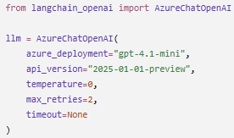
Can you explain this object?
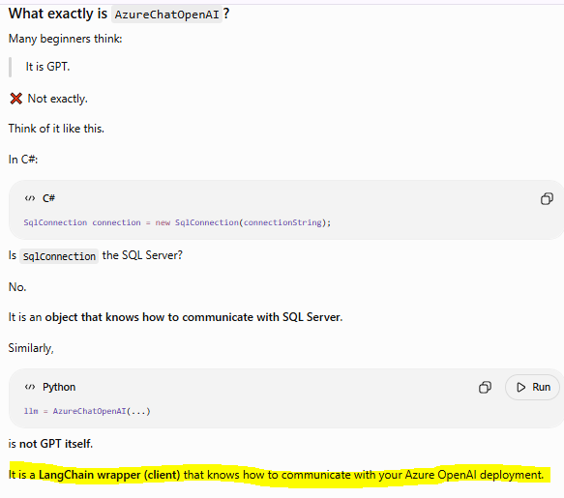
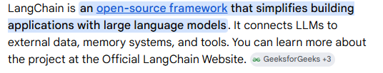
It actually originated as a Python library before expanding. Today, it officially supports both Python and JavaScript/TypeScript.
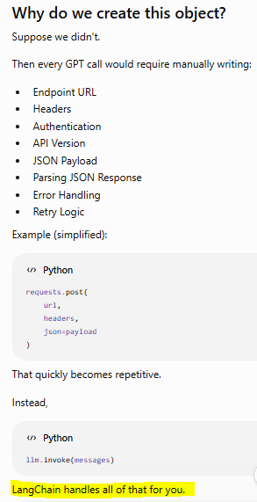
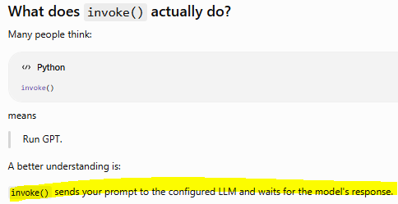
You can think of it like:
In C#:
await httpClient.PostAsync(...)
except LangChain hides all the networking details.
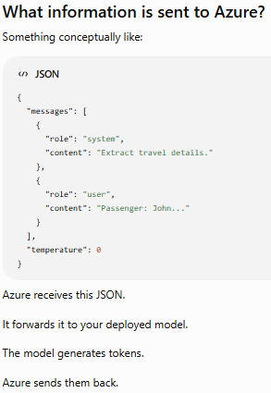

Why do we say "Azure Deployment" instead of "Model"?
This is one of the most common Azure OpenAI interview questions.
You didn't write:
model="gpt-4.1-mini"
Instead you wrote:
azure_deployment="gpt-4.1-mini"
Why?
Because Azure works differently from OpenAI.

OpenAI
Your Code

↓

model="gpt-4.1"
The API directly selects the model.
Azure OpenAI
First you create a deployment inside Azure.
Example:
Deployment Name

↓

gpt-4.1-mini
Behind that deployment Azure maps:
Deployment

↓

Actual Model
Your application only knows the deployment name.
This gives administrators flexibility to update or swap the underlying model without changing application code.
Q: What is AzureChatOpenAI?
AzureChatOpenAI is a LangChain integration class that acts as a client for Azure OpenAI. It stores the configuration required to communicate with an Azure OpenAI deployment and provides methods like invoke() to send prompts and receive responses from the deployed language model.
Q: What happens when you call invoke()?
invoke() packages the prompt and conversation messages into a request, sends them to the configured Azure OpenAI deployment over HTTPS, waits for the model to generate a response, and returns that response to the application. LangChain handles the request formatting and response parsing.
• AzureChatOpenAI is not the LLM; it is the client/wrapper used by LangChain to communicate with Azure OpenAI.
• Creating the object does not call Azure.
• The Azure API call happens when methods like invoke() are executed.
• Azure uses deployment names, not direct model names, so infrastructure teams can manage models independently of application code.
• LangChain simplifies authentication, request formatting, retries, and response parsing.

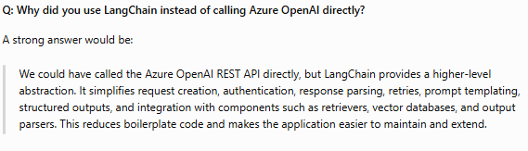
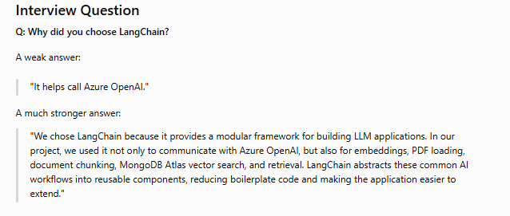

Which LangChain Features Have We Used?
Let's map it to your project.
LangChain Feature | Used? | Where
AzureChatOpenAI | ✅ | LLM calls
AzureOpenAIEmbeddings | ✅ | Embeddings
PyMuPDFLoader | ✅ | PDF loading (RAG POC)
RecursiveCharacterTextSplitter | ✅ | Chunking
MongoDBAtlasVectorSearch | ✅ | Vector search
Retriever | ✅ | RAG POC
PromptTemplate | ❌ (we mostly used manual prompts)
OutputParser | ❌
Agent | ❌
Memory | ❌
Tools | ❌

